CUNEIFORM
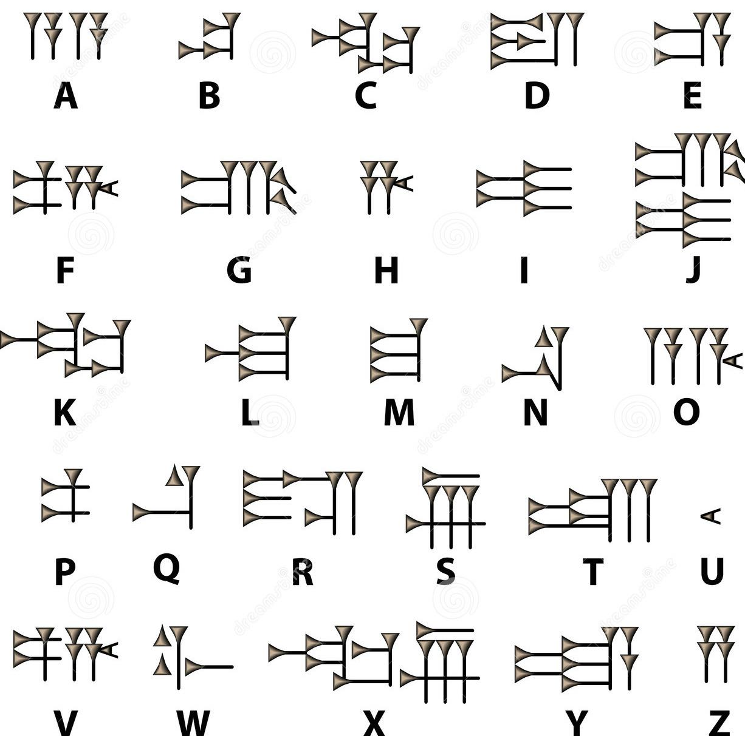

Above is the ancient Sumerian alphabet written in cuneiform, the world’s oldest form of writing. Use this paper to help you write your own first and last name in cuneiform on a blank piece of paper. Use the art supplies available at this station. Do your best to make it look nice!

