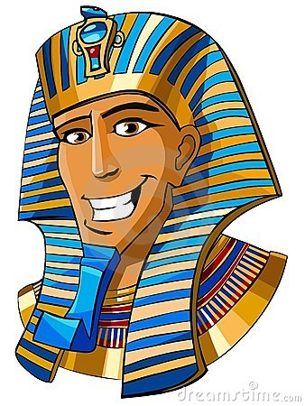
Ancient Egypt
Pharaoh WANTED! Poster
Use the construction paper provided to create a WANTED! Poster. The poster must include:
- The name of the Pharaoh
- Time period “last seen in_________ BCE, the __________kingdom. (Old, Middle, New?)
- Description: At least 2 things they are “known” for: accomplishments and/or negative actions
- Known accomplices (people that they work with). Must choose someone.
- Where to look for them/where they could be hiding (monument or city related to him/her)
- A reward! (Think about currency or something valuable from that time period)
- Known aliases (nicknames) “Also known as…”
- Colorful illustration of your pharaoh
Pharaohs and Page Numbers (HA=History Alive, AC=Ancient Civilizations)

- Tutankhamen (AC Pg. 184)
- Akhenaten / Amenhotep (AC Pg. 183)
- Khufu (HA Pg. 75, AC Pg. 170)
- Ramses II (HA Pg. 78-79, AC Pg. 184-185)
- Hatshepsut (HA Pg. 77 AC Pg. 181-2)
- Senusret I (HA Pg. 76)

Ancient Egypt
Pharaoh WANTED! Poster
Use the construction paper provided to create a WANTED! Poster. The poster must include:
- The name of the Pharaoh
- Time period “last seen in_________ BCE, the __________kingdom. (Old, Middle, New?)
- Description: At least 2 things they are “known” for: accomplishments and/or negative actions
- Known accomplices (people that they work with). Must choose someone.
- Where to look for them/where they could be hiding (monument or city related to him/her)
- A reward! (Think about currency or something valuable from that time period)
- Known aliases (nicknames) “Also known as…”
- Colorful illustration of your pharaoh
Pharaohs and Page Numbers (HA=History Alive, AC=Ancient Civilizations)

- Tutankhamen (AC Pg. 184, HA Pg.73)
- Akhenaten / Amenhotep (AC Pg. 183)
- Khufu (HA Pg. 75, AC Pg. 170)
- Ramses II (HA Pg. 78-79, AC Pg. 184-185)
- Hatshepsut (HA Pg. 77 AC Pg. 181-2)
- Senusret I (HA Pg. 76)

