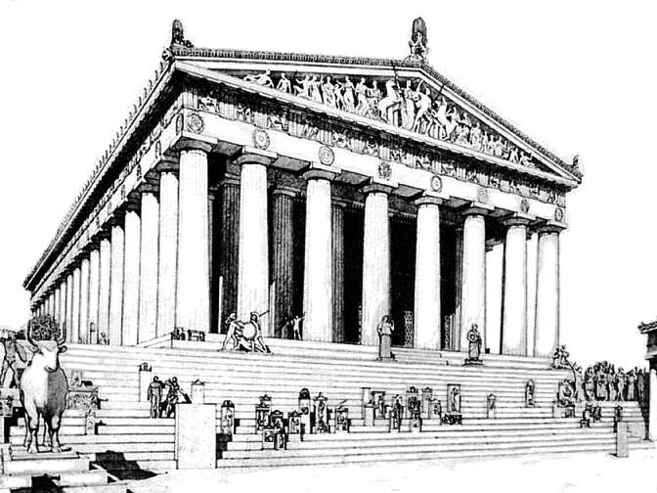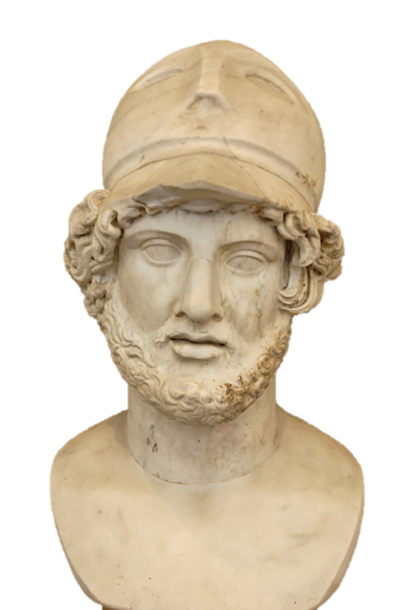

**The Parthenon**

Describe the **Delian League**? What was its goal? Where was its headquarters and Treasury?

What job(s) did **Pericles** have in Athens?

How did Pericles help Athens dominate the Delian League?

What were Pericles’ beliefs about **democracy?** Provide at least three examples to support your claim.

How did Pericles help Athens’ culture flourish/grow into a Golden Age (time of prosperity) under his rule?

What was Pericles’ goals for Athens? How did he try to accomplish that goal?

**Pericles 495-429 BCE**

**Directions:** Use the Ancient Civilizations Textbook Pages 359-361 to answer the questions below Name________________________