Name_____________________________
Time Periods in Ancient Egypt
Historians divide the time in Ancient Egypt into three periods: The Old Kingdom, the Middle Kingdom, and the New Kingdom. Each period has unique characteristics that make up that period.
Directions: Use pages 166-169, 179-180, and 180-186 to complete the timeline below. Choose as many events, people, or places that you can find.
1670 BCE
2300 BCE
2050 BCE
1550 BCE
3100 BCE
2600 BCE
1080 BCE

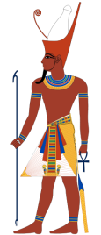
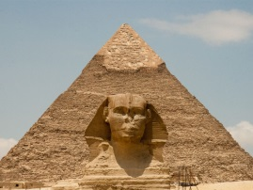
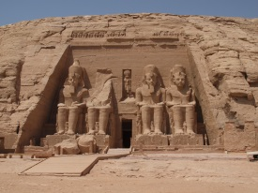

Determine the timespan of the Egyptian Empire__________________________________________________________________________________________
Why are the years decreasing?________________________________________________________________________________________________________

