“ I long for home, long for the sight of home. If any god has marked me out again for shipwreck, my tough heart can undergo it. What hardship have I not long endured at sea, at battle! Let the trial come . . .”
~ Odysseus

The Voyage of Odysseus
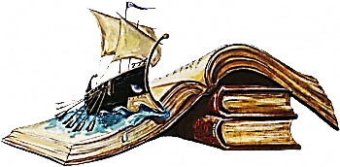

The Voyage of Odysseus

Based on Homer's epic story of the Odyssey

Retold by Margaret H. Lippert (ORACLE Think Quest)

with editions and additions by Laura Young

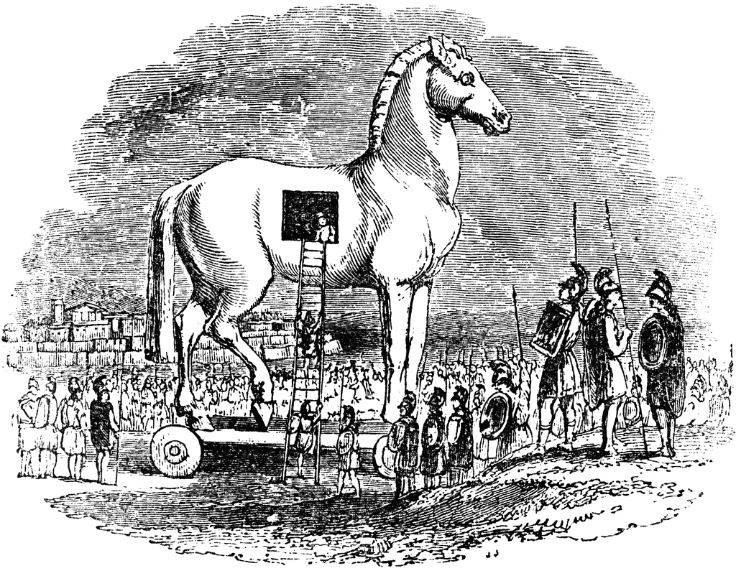

The story of Odysseus is one of the oldest in the world. It was composed over three thousand years ago by a Greek poet named Homer. He wrote the Iliad, which is the legend of the Trojan War, and the Odyssey, which describes the return voyage of the Greek king, Odysseus.
Long ago, Odysseus was a king of Ithaca. At the start of the war, Odysseus had not wanted to leave his home, a beautiful island off the coast of Greece. He loved his wife Penelope and their infant son, Telemachus. But King Menelaus of Sparta needed his help. So Odysseus set sail with other princes and kings of Ancient Greece. They went to Asia Minor to help King Menelaus recapture his wife, Helen, who had been abducted by Paris, a young prince of Troy. This was the beginning of the war that would last ten, long years until Odysseus had the idea to trick the Trojans with the use of an enormous wooden horse.
With the fall of Troy, Odysseus and his men set sail for home. The Odyssey is the story of their fateful voyage.
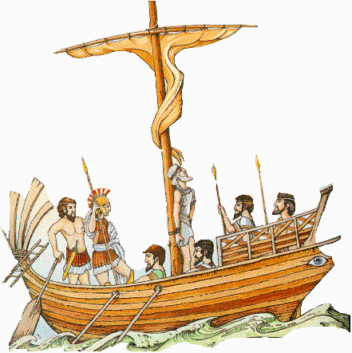

The twelve ships that set sail under Odysseus’s command were packed with nearly fifty men each and ships’ holds filled with confiscated treasure taken from Troy. Only a few days’ supply of food and water could be stored onboard in those days, so ships often traveled close to the coast in order to land and resupply as needed. Their travel home might have only taken weeks, but the whims of men and gods caused this particular voyage to last for ten years.
The journey began peacefully at first, but greed over treasure caused problems soon enough - greed and the wrath of the sea god, Poseidon, who was displeased at the fate of the Trojans. For the goddess Athena had sided with the Greeks in the Trojan War and Poseidon, her uncle with whom she had long since been at odds, had sided with the vanquished Trojans.
How could there not be suffering in this story when the hero’s own name meant “trouble”? Cleverness was a trait often valued by the gods and Odysseus was indeed a clever man. But intelligence and skill, not tempered with humility, can lead men to ruin. Was it bad luck or bad decisions that determined the fate of Odysseus and his men? You will have to decide, but bad luck often makes for good stories.

The story begins . . .
For twenty long years Telemachus and his mother waited for Odysseus to return. The Trojan War had been over for ten years, but still Odysseus had not come home. Telemachus decided to embark on his own voyage, to seek news of his father.
Telemachus stood before King Menelaus, the ruler of Sparta. He wanted, more than he had ever wanted anything, to hear that his father was still alive, but he was afraid that he would be told that his father was dead. He suddenly realized that King Menelaus had addressed him, and he tried to reconstruct what he had heard. The king was speaking again. "Telemachus - son of Odysseus - what brings you here?"
"Your Majesty,” Telemachus began, "I seek news of my father. He has not returned home yet from the Trojan War, and I am afraid that he may be dead. The kingdom of Ithaca is in turmoil. My grandfather, Laertes, is too old to rule and wicked men are trying to seize power." His words were tumbling out rapidly, as he explained the tragedy that had befallen his homeland. "My mother is besieged by suitors who, in my father's absence, have moved into our palace. Each one wants to marry her and take for himself what rightfully belongs to us. For years she has put them off, but now they are becoming more impatient and she may soon be forced to choose one of them."
King Menelaus nodded. He understood the disorder of a kingdom without a king.
Telemachus continued. He spoke more slowly now and his eyes never left the king's face. "Your Majesty, I want my father to come home. I need him, my mother needs him, and the kingdom of Ithaca needs him. We have waited for him these ten, long years though we do not know whether he is alive or dead. If you know, tell me. Do not spare me."
"Telemachus, you are truly your father's son. He would be proud of you because you are not afraid to seek the truth. My news is mixed. Your father is alive, but he is being held captive by a nymph named Calypso. Seven years ago she rescued him from a storm; since then she has kept him on her island against his will. All of his companions have perished, his ships destroyed, and he has no means by which to escape and return home."
In spite of the news that his father was a captive, Telemachus was overjoyed. "If Odysseus is alive there is still hope that he will come home," he said. "I must return to Ithaca to tell my mother." Telemachus left the palace at once. He sprang into his chariot and was off. It would be a long journey: First, two days along rocky roads to the coast where his ship was anchored, then a full day of sailing from there to Ithaca. Telemachus did not want to waste time.
As Telemachus traveled, the gods gathered for a meeting on Mount Olympus. It was their custom to discuss the events of men and to interfere when they wished. Each god and goddess had mortal friends and enemies, depending on who had pleased or angered them. Athena had befriended Odysseus while her uncle Poseidon wanted to destroy him. Athena took

advantage of the fact that Poseidon was traveling in Ethiopia at the time. She could discuss Odysseus with Zeus – the king of the gods - without Poseidon's interference.
"Father Zeus," said Athena, "Odysseus has suffered long enough. For ten years he fought the Trojan War in which the Greeks were victorious because he devised the trick of the huge wooden horse. For the next three years he voyaged home, confronting and overcoming numerous hardships. For the past seven years he has remained captive on Calypso’s island of Ogygia. During the long years he was away, Telemachus grew into manhood - a brave son who recently ventured forth to seek news of his father he knew only through stories. I ask you now," pleaded Athena, "to assist Odysseus in returning home."
In Poseidon's absence, Zeus was able to take action to help Odysseus. He sent Hermes to Calypso with a message that she was to release Odysseus and allow him to return to Ithaca.
Calypso had to obey. Although she would miss Odysseus terribly, she did not want any harm to come to him. Thus she decided to assist him in building a seaworthy raft for his voyage home. Odysseus was overjoyed. Thoughts of his family and of the land he loved flooded over him as he set to work on the boat that would carry him home.
First, Calypso showed Odysseus a place on the island where tall, straight trees grew. With an axe that she loaned him, Odysseus cut down twenty trees, smoothed them, and tightly fastened them together with wooden pegs. At the stern of the boat he built a rudder to guide his vessel. Around the perimeter, he made a low wall of tightly woven rushes. He set a tall mast in the center of the raft and fashioned a yard-arm across the mast to control the sail. Calypso presented Odysseus with a sail and with provisions for the voyage: a large skin filled with fresh water, a heavy sack of corn, and some special delicacies that she made for him so that he might enjoy the voyage and remember her friendship. When all was ready, Odysseus set off. As a parting gift, Calypso called forth a warm, gentle wind. Odysseus set sail then and turned toward home.
For seventeen days and nights Odysseus sailed, navigating by the sun during the day and by the stars at night. On the morning of the eighteenth day he sighted the shore of Phaeacia which was only a day's sail from Ithaca. Joyfully, he looked up to adjust his sails but was surprised and dismayed to see dark storm clouds gathering overhead. Before long the clouds had thickened and blocked out the light of the sun. The wind picked up and the waves began rolling over the sides of the raft. As lightning flashed and thunder roared over the sea, the waves mounted higher and higher.
The storm was the work of Poseidon who was on his way back from Ethiopia to Mount Olympus when he had spotted Odysseus. Furious that Zeus had arranged for Calypso to free Odysseus, Poseidon was determined to prevent his arrival home. To finish off Odysseus, Poseidon sent a mountainous wave which broke over the boat. Odysseus was washed overboard and was plunged deep into the raging sea. Poseidon then continued to Mount Olympus to vent his fury against his brother.

Odysseus struggled to get his head above the water. Finally, his head broke the surface of the sea, and he took huge gulps of air. He looked around for his raft, but it had been torn apart by the force of the mighty waves. The beams that once joined the craft now floated singly on the waves. One log bobbed not far from Odysseus and, realizing it was his only hope, he swam toward it. With the little strength he had left, Odysseus managed to lock his arms around it so that he could not be dislodged. Totally exhausted from his ordeal, he lay face down on the log, thinking only of his wife and son.
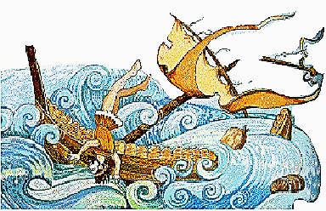
Athena, who had been watching and waiting for the departure of Poseidon, now calmed the storm winds and sent a strong onshore breeze to carry Odysseus toward Phaeacia. For two days he floated steadily toward land. On the morning of the third day, Athena guided Odysseus between the jagged rocks that dominated the coast to a safe landing on a sandy beach, at the mouth of a river. Odysseus lay on the shore, wet and cold, and realized at once that he must find a warmer place to rest if he still hoped to survive. He staggered up the beach to the woods that came down to the sand and crawled through the undergrowth until he came to a clearing, carpeted with a thick layer of leaves. There he fell into a deep sleep.

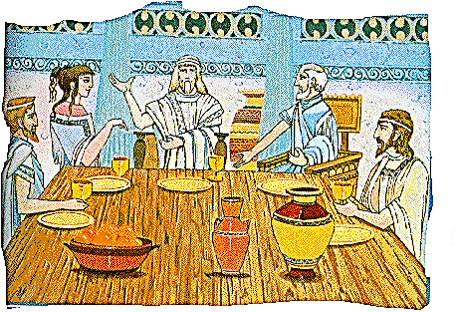 | Odysseus was awakened by the sound of voices. He peeked through the trees to see a group of young women playing ball by the river. Seeking information that would help him get home, he approached them. One maiden seemed to be the leader and she told him that her name was Nausicaa. She was the daughter of King Alcinous of Phaeacia. Although she did not know who the stranger was, she realized that he needed help. She gave him some food they had brought with them and then took him back to the palace with her.
At the palace, King Alcinous was told of the arrival of the shipwrecked traveler. He ordered a feast prepared in honor of the visitor, and Odysseus was led to a seat next to the king.
"What good fortune that you have landed on our shore," said the king. "You must have marvelous tales of your travels to relate. But first tell us your name, where you come from, and where you are bound."
"You are most gracious, Your Majesty," responded Odysseus, "to welcome a stranger so warmly to your palace. Your kindness is matched by that of your daughter who assisted me when I was near death and so saved my life. I hope that I will be as proud of my own son when I return home as you must be of your own resourceful daughter. But here I am, thinking of my home, when I still have not told you my name. I am Odysseus of Ithaca."
The King was astonished to be seated by the legendary Odysseus, hero from the Trojan War, and long-lost wayfarer. "You are Odysseus, son of Laertes?" he asked.
"Yes," replied Odysseus, "I am."
"Then you are the rightful King of Ithaca. Your father is too old to rule and your wife and son bravely await your return. Tomorrow morning you will take one of my ships to Ithaca. My sailors will see you safely home."
"Thank you. I appreciate both the generous loan of your ship and the haste with which I may set sail."
"But now," King Alcinous continued, "we have a whole evening before us. Tell us about your journey, your adventures, and your misfortunes. Why has the voyage from Troy to Ithaca, which can be made in a week’s time, taken you years?"
"Telling you the story of my journey is the least I can do to repay your kindness," Odysseus said. "It is a story that begins with twelve proud ships and ends with one survivor. It begins ten long years ago and ends this morning, on your shore. It covers many lands, many people, and many misadventures.”
Odysseus continued, "Ten years ago twelve ships, carrying nearly fifty sailors each, left Troy with me. The wind bore us northward towards Thrace to Ismaros, the land of the Cicones and allies of the Trojans. As allies to Troy, the Ciconians were enemies to us as well. Ten years of war had made my men savage as wolves and we plundered their town so that we might return home with more treasure. Then I ordered the men back to the ships so that we could depart before the Ciconians had time to retaliate. My men did not heed me. Rather, they lingered to drink wine and make merry all night. The townspeople then gathered men from the neighboring countryside to join them in attacking us. My men were in no condition to fight and, by dawn, more than seventy of us lay dead along the beach.”

The Lotus Eaters

"We mourned our lost comrades but gave thanks that we ourselves had been spared. We had not sailed far when a bitter north wind began to roar over the ocean. I ordered the men to lower the sails so they would not be ripped to shreds. For two days we rowed then, on the morning of the third day, the storm subsided so that we could raise the sails and be carried again by the wind. With luck we would have rounded Malea and returned home in a day or two, but the wind and current conspired against us and pushed us far off our course.”

"For nine days we fought the elements and on the tenth we came to a strange land. We drew fresh water from a spring and, after our midday meal, I sent three men to explore. The men never returned, so I went with several others to seek them. We found them bewitched. The people of that land were kindly enough for they ate nothing but the fruit of the lotus flowers that grew there. Whoever tasted the fruit lost all knowledge of past or future, dreaming and forgetting all else. My men had been given lotus plants to eat which made them languid and forget who they were. ‘Get up, you worthless jellyfish!’ I roared at them, but it was no use. I had to have them carried back to the ships. Then again, we set out for the open sea.”

The Cyclops

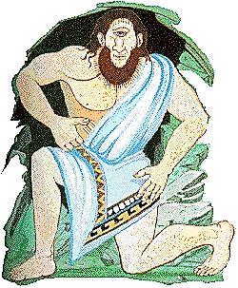 | "We sailed on and came to the land of the Cyclopes, a giant people. They do not cooperate with one another as we do. Each family lives in a separate cave and tends a herd of sheep and goats. I decided to go ashore to seek provisions for our voyage. Ordering the other boats to wait for us at sea, I sailed on into the harbor.”  "As soon as we had anchored, I selected twelve of my strongest companions to accompany me. Wishing to take a gift for our hosts, I filled a large wineskin with very strong wine.”  "Above us, on the hillside, we could see a large cavern. We climbed upwards and, seeing no one, entered the cave. At the back of the cave were pens filled with goat kids and lambs. Bowls and containers of every description lined one side of the cave and great cheeses were stored on shelves above them. In the center of the floor was a smoldering fire.”  "My companions begged me to take some cheeses and leave immediately but, unfortunately, I did not heed their advice. I wanted to address the occupant and request gifts that we might take with us.”
"At twilight we felt the ground begin to shake. We looked up to see a monstrous giant at the entrance. He had the form of a massive man but had only one eye, which was right in the center of his forehead. We shrank back in fear and watched him guide his flocks of sheep and goats into the cave. After rolling a boulder to close the entrance to the cave, the Cyclops sat

down to milk the ewes and nanny goats. Then he set half of the milk aside for his supper and curdled the rest to make cheese. When he was finished, the Cyclops stirred the fire. We had been watching all of this in frozen horror. Then one of us moved. The movement caught the monster’s eye and his voice came thundering toward us: 'Who are you who dare come uninvited into my home?'”
"My men were speechless, but I answered, 'We are heroes of the Trojan War who have come to ask you for gifts to take home with us.'”
"The giant roared with laughter. 'You ask for gifts from Polyphemus, a son of Poseidon? What have you to give me?'”
"I brought forth the wine and offered it to him. He took it and greedily drank his fill. 'This gift is good,' he said. 'Tell me your name, and I will give you a gift after all.'”
"I answered craftily, 'My name is Nobody.'”
"Nobody, my gift to you is that I will eat you last,' he laughed and at once he picked up two of my men. Before we could rescue them, the one-eyed monster swallowed them whole, washed down by the milk he had saved.”

"The rest of us would soon be dead unless I could devise a plan by which we could escape. I encouraged Polyphemus to have more wine so that he would fall into a deep sleep and, when he was snoring, we set to work.”
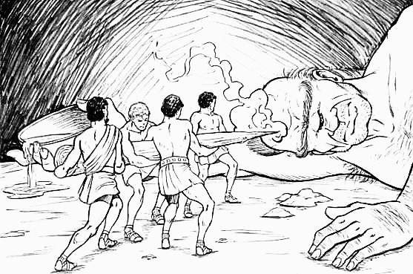

"There was a huge wooden log in the cave, from which we cut off a piece about a fathom long. This we smoothed and sharpened to a point, then we heated it in the fire. When it was ready to burst into flame, we thrust the red-hot poker into the sleeping giant’s eye, blinding him instantly. He leaped up in frightful agony and cried out for help. His neighbors, hearing his pleas for help, came running.”

"Move the rock away,' Polyphemus called, 'and let me out. Nobody has blinded me! Nobody is harming me!’ When the other Cyclopes heard that, they went away, calling back to him that if “nobody” had injured him, then surely it must be the gods punishing him.”

"Now, Polyphemus was terribly angry. He was determined to catch us as we tried to escape from his cave. He moved the rock aside a little and blocked the opening with his huge hands so that he could grab us and eat us as we ran out.

I then thought of a trick whereby we could leave safely: I bound each of my men to the underside of a sheep and tied the sheep together in groups of three. As the sheep began to leave the cave to go to the pasture, Polyphemus felt along the backs and sides of each group to see if we might be riding the sheep to safety. But he never thought to check underneath the sheep and so my crewmates escaped. I myself was the last one out and, because there was no one to tie me on, I simply clung to the wool on the belly of the largest sheep and so escaped with my men.”
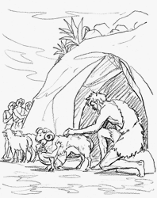

"We rushed back to our ship and weighed anchor. I was thrilled that my ruse had worked so well against the Cyclops, I could not resist a parting taunt to the beast.”

“Thus I called back over the water, 'Polyphemus, son of Poseidon, it was not Nobody that blinded you but Odysseus himself!' Alas, my foolish pride would later prove to further our troubles. By giving Polyphemus my true name, I would give it to the god Poseidon as well. As the Cyclops stood before us, Polyphemus broke off the top of the cliff on which he stood. In his rage, he heaved the boulder in the direction of my voice. It just missed our ship and the wave it caused pushed the vessel to where the rest of the fleet waited, out of danger.”
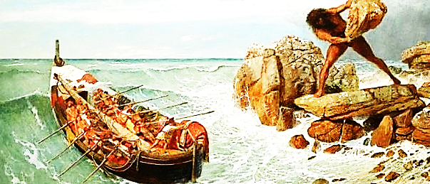

The Lord of the Winds

"Our next stop was the island of Aeolus, Lord of the Winds, where we spent a month entertaining the kind Aeolus with tales of the Trojan War and all of our adventures thus far. On our departure he gave me a bag tied with silver cords which contained the storm winds. He directed me not to open the parcel – under any circumstances – until our ships were safely tied in our own harbor. We sailed for nine days. The winds were favorable, but I trusted no one save myself to man the steering-oar. All the while my men grew more curious about what might be in the bag Aeolus had given me. Exhausted, I finally fell asleep.
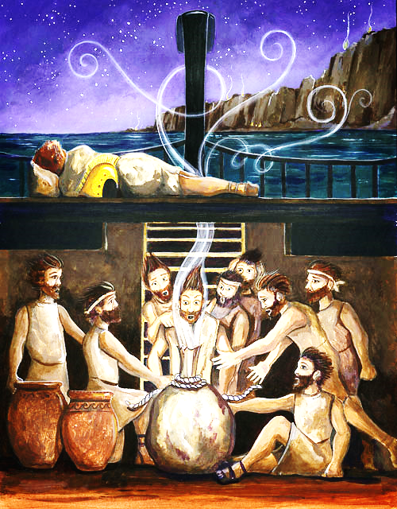

As I slept, our homeland finally came into sight. Overjoyed at the prospects of returning home, my sailors were even more envious of the bag I kept so carefully hidden. They were convinced that I must be keeping some sort of treasure from them and they impatiently opened the package containing the fierce winds. The winds escaped and blew us back the way we had come, beyond the Aeolian Islands, to the land of Laestrygones.”

The Laestrygonians

"There we saw a lovely harbor so enticing that all the other ships entered it. Although the land itself was beautiful, we were to learn that the people who resided there were not. They, too, were gigantic people who devoured humans. I alone was suspicious from the start and ordered my ship anchored outside the harbor. Several unsuspecting sailors went up to the town and were shown to the palace of the king. There they were attacked and killed by the king and his family, even as the king was giving orders for our ships to be destroyed. The Laestrygones stormed down the cliffs and hurled rocks onto the helpless sailors. All eleven ships, and every man aboard, were lost. Our ship alone was saved because we had not entered that awful place. Swiftly, I cut the anchor rope that we might escape, and we sailed off, grieving for our lost comrades. For now, out of twelve ships and their valiant crew, only one survived.”

The Enchantress

"Before long, we came to the island of Aeaea, home of the enchantress Circe. For two days we lay on the beach too weary to do anything more. On the third day, I ventured to the top of a hill so that I might survey the land. From my vantage point, I saw miles of forest with no sign of anyone living there except for a plume of smoke, far off in the distance. I divided my men into two companies to be led by myself and Eurylochus, a kinsman of mine. Putting our two names in a helmet, we drew names to see which company would search the land. Eurylochus’s name was drawn and he and his men set off.”
“By the end of day, Eurylochus returned badly shaking and weeping. He was alone. At last he calmed and was able to tell what had happened: They had come to a stone house where a woman sat weaving. One of the men called out to her and she left her weaving and bade the men to enter her house where she served them food and wine. Eurylochus, sensing a trap, stayed behind and hid while his men entered the house. The men were quite famished and ate hungrily. While they ate, the woman tapped each man with a slender stick of wood. As she touched them, the men grew bristles and a snout. She had turned them into pigs.”

“Eurylochus was now too frightened to join me so I set out, alone, to free my men. Along the way, I was met by the messenger god Hermes who gave me an herb which would protect me from the powers of Circe. I kept the plant hidden under the breast of my tunic.”
“Upon finding Circe, the enchantress also bade me to enter her home and eat. She was startled to find, however, that her magic had no effect on me. Fearing the wrath of the gods, she agreed to change my men back to their human forms. We all came to Circe’s home and ate the feast that she and her maidens made for us.”
“But Circe’s enchantment prevailed and the days passed so pleasantly that a year went by before anyone, even I, had noticed the passing of time. As we began to think of Ithaca once more, I called upon Circe to tell me how we might find our way back. She did not have the answer but suggested we see the ghost of the blind prophet - Tiresias of Thebes – who now resided in the Land of the Dead with Hades, so that I might ask him to foresee the future and tell me what I must do to return home.”

The Land of the Dead

"We set sail for Oceanus, the deep-flowing river that lies at the end of the world. There the land is wrapped in mist and never sees the sun. I went ashore and entered the underworld.”

“By making offerings, I found the spirits of many of those who had past, including my own mother who had died from grief over the many years that I was away. The spirit of Tiresias reassured me that I would survive many tribulations and return home to die an old man, at peace.”
Perils at Sea

"I returned to my ship and sailed back to Circe. She warned me of dangers we would encounter on our homeward voyage and told me how I might best overcome them. Then we departed.”
"The first peril was the song of the Sirens which was said to be so sweet that unsuspecting sailors were lured to their deaths on the rocks. Circe had advised me to have myself bound to the mast so that I might listen to the song without endangering the lives of my men. To protect the other men, I was to fill their ears with beeswax so that they could not hear the bewitching song. I did as she advised me. The sirens called to me with voices dripping with honey, ‘Come nearer Odysseus, hero of Greek men. Listen to our song for all things are known to us. Do you not have questions you long to be answered?’ Overcome by the lovely song, I struggled to get free and sail to my death, but the sailors bound me more tightly. Not until we were safely by did they remove the wax from their ears and free me from my bonds. The first of Circe’s perils was passed.”
"The next hazards were the threats of Charybdis and Scylla, who dwelt on opposite sides of a strait so narrow that an arrow could be shot from one side to the other. On the one side of the waterway was Charybdis - a churning, boiling whirlpool that sucked down the sea three times a day and three times vomited it up again. Across the channel lay Scylla, a creature with six heads on long, thin, scaly necks that plucked six sailors, one for each head, from every boat that passed and ground them with her terrible teeth. Circe had advised me to sail as far from Charybdis as possible, though by doing this I would come close enough to Scylla to lose six men. With a heavy heart over my dismal choices, I ordered the ship be sailed further from the whirlpool so that I might not lose my entire ship and every one of my men. Scylla was indeed hungry. I could only be thankful that most of us had been spared.”
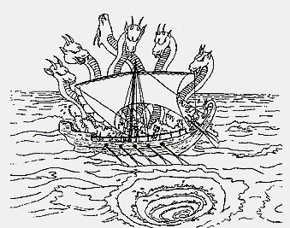

"The last danger was one that proved to be the downfall of the rest of my men. Circe warned that we should not hunt the cattle of Helios, the sun god, on his island. When we arrived there all went well at first. My men feasted on food given to us by Circe, and they did not disturb the cattle. Then the wind shifted so we could not sail. We were forced to stay there a month, our food ran out, and my men grew restless. At last one day they did kill some of the fattest cows. When we finally set sail, Zeus sent a thunderbolt to strike our ship in retribution. The mast crashed to the deck, the ship was destroyed, and all of my companions were drowned. I alone was spared. I rode for ten days on a piece of the ship’s mast and finally was carried to Ogygia, the island of Calypso, where I was held captive for seven years and from which I have now come."
The Return Home

With the conclusion of Odysseus’s story, King Alcinous sighed. "The gods seem to both favor and curse you, Odysseus. But come, it is time to rest, for you have the long-awaited end to your difficult journey before you tomorrow."
In the morning, King Alcinous bade Odysseus farewell and showered his visitor with gifts. After loading the ship, they were off. Now relieved of having to captain and navigate the ship himself, Odysseus fell asleep. When the ship arrived, the sailors gently carried Odysseus to shore and laid him on the soft grass with his possessions around him.
Upon waking, Odysseus hid his gifts in a nearby cave then went to look for assistance. Athena appeared to him and advised Odysseus to enter the palace disguised as beggar so that he might gain an advantage over the traitors living there since it would allow him to act without the others knowing of his return. First, however, Athena arranged a special welcome for Odysseus. She led him to a nearby hut then brought a young man to greet him. Odysseus took one look at the man and thought he saw himself standing there. For a moment he was confused until he realized that it was not himself he was facing but his own dear son, Telemachus, now grown.
He took Telemachus in his arms and wept for joy. "Father," gasped Telemachus, “it really is you. I knew you would come back to us. When I heard you were still alive after all these years, I returned home to wait for you. I cannot believe my waiting is over."
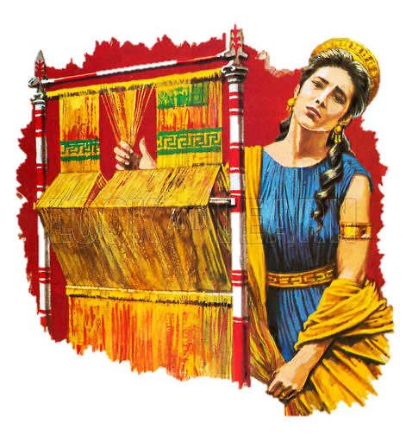
"Telemachus, my son, I never stopped thinking of you. I never stopped dreaming of you. But I never knew how much I loved you until this very moment. Now, sit down and I will tell you the plan for defeating those who have betrayed our trust." Father and son talked together long into the night. From Telemachus, Odysseus learned how his wife Penelope had delayed her suitors. She vowed she would announce her choice of husband when she had finished weaving her tapestry. Every day she worked at her loom, but every night she undid the work she had that done that day so the cloth was never finished.
As the moon rose, Odysseus said, "Now it is time for you to return to the palace. Remember, tell no one I have returned. We must surprise our enemies. Soon they will be destroyed, and peace will return to our land."
Telemachus rose and walked to the door of the hut. He embraced his father then stepped out into the moonlight. Odysseus watched his son until his shadow blended into the night and he could see him no longer. Then he turned and entered the hut. His voyage was over, but the next day a new struggle would begin. Love for his brave son and his faithful wife filled him with joy, and he looked forward to the new day.
As the sun awoke, so did Odysseus. It was the custom of those days to offer hospitality to all passing travelers, so Odysseus did not hesitate to approach the palace. There he settled in the doorway of a darkened hall to wait. He did not have long to pause when Penelope and her maidens entered. Startled at first to find what appeared to be a beggar in their midst, the maidens tried to shoo Odysseus away from their queen but Penelope, entering close behind, heard their discourteous chattering and scolded the women for their ungraciousness. She ordered a fire to be made for the beggar man and sat down beside him.
Some might think it odd that Penelope would not recognize her own beloved husband - disguised as a beggar or not – but Athena’s magical deception proved effective. Penelope found herself at ease with the stranger. She was wanting for company so she began to tell him of her sorrow that her lord Odysseus had not returned even after all these years. Odysseus listened with a heavy heart but encouraged the queen to continue. Penelope lamented that, if Lord Odysseus did not soon return, she must yield and take one of the suitors for her new lord. How could she choose among them when she wanted none?
“Call a contest,” Odysseus suggested as the beggar man, “and give yourself to the winner.”
Penelope made no reply at first but realized the truth in what he said. After a while, she sighed and answered, “I recall my husband would take twelve ax-rings that men use for target practice, set them in a row, and shoot an arrow straight through all twelve for a show of skill. So it will be. There will be a contest with Odysseus’ bow and arrows. Whichever man can shoot his arrow through the rings I will take for my new lord.”

The Archery Contest

The suitors lounged about the courtyard, waiting their turns and laughing at the other men’s attempts. One after another each tried and failed to even string the great bow of Odysseus because it required such great strength to do so. Then Odysseus, still disguised as the beggar, approached. He took up the bow, quickly stringing it, and then nocked an arrow to the string. In one swift motion the arrow flew as it passed cleanly through all twelve ax-rings. The other men grumbled their displeasure. “Now I will shoot at another mark that no archer has yet found!” Odysseus thought. Odysseus nocked another and another arrow to his bowstring, aiming them at the suitors. “Dogs!” he shouted at the men. “You thought that I should not return from Troy and so you squandered my belongings and laid claim to my wife and kingdom. Now the time of reckoning has come upon you all!”
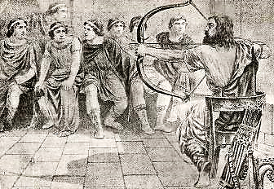
With a signal from Odysseus, Telemachus joined in the fight with his spear. The suitors scrambled to arm themselves and fight against Odysseus’ arrow-fire. Observing all that was occurring from her viewpoint atop Mount Olympus, the goddess Athena once more came to the aid of Odysseus. She sent out her power so that when the suitors tried to throw their spears or draw their swords against Odysseus or Telemachus they missed their mark while the blows by Odysseus and Telemachus killed each man they were aimed at. When all was done, dead men were strewn about the room like fallen leaves around a tree.
“Who was this stranger that has slain all of the suitors?” the servants whispered to each other as news of the destruction quickly traveled through the palace. Their words made their way to Penelope who was awakened from a deep sleep that Athena had cast upon her before fighting in the courtyard began. She came to the great hall to find the old nursemaid, Eurycleia, tending the minor wounds of Telemachus and Odysseus on the other side of the room. Upon seeing Penelope, the old nurse nearly ran to her. “Come see what you have longed for, for so long: Odysseus returned to us and all of your suitors gone!”
“Old nurse,” Penelope replied, “you must not be right, for this man is not Odysseus.”
“He bears the scar on his leg which I know marks the skin of my master,” said the nurse laughing with joy. Still Penelope dared not believe. She watched the stranger from across the room looking for signs of Odysseus that she might recognize in the man, but the disguise was still working. Suddenly Penelope knew how she might test the stranger with information few people would know. As she walked towards him she said, “Eurycleia, our guest must be tired. Make up a bed for him. You may use the one from my chamber.” Odysseus heard Penelope’s suggestion and remarked, “How can anyone bring our bed from where it stands? I made the bed myself from the olive tree that grows there. Only be cutting down the tree could that bed be moved!” With that, Penelope knew that somehow this man before her was her beloved Odysseus returned. She flung her arms around Odysseus’ neck and clung to him as though she would never let go.
Telemachus came to join them as they sat by the fire. Holding Penelope close, Odysseus told them of his wanderings through strange places and stranger circumstances. Tomorrow Odysseus would visit his father and share the news of his return but tonight . . . tonight Odysseus would savor the glow of the fire and the glow of happiness shining on the faces of his wife and son.

